**D2 – Compare the effectiveness of different transmission methods**

**Introduction**

In this report, I will be comparing both fibre optic and coaxial cable in detail. I will first name them both and say the similarities and differences of both of them. After, I will say any problems it has with the solutions. Then, I will name any environmental issues that they both have and lastly I will link it to the OSI or TCP/IP model.

**Coaxial vs. Fibre Optic**

**Fibre Optic**

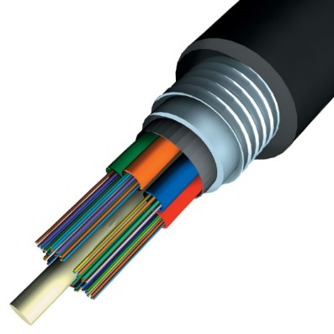A fibre optic cable contains dozens of strands. Approximately, each strand is as thin as one human hair. If it were that thin, it would take time to cable. Therefore, the disadvantage is that it would need professional person to insert these strands and cable it in. However, the advantage is that it transmits data through light rather than electricity. Referring to Figure 1.1, it shows how a fibre optic cable looks like. These high-intensity light beams are generated by lasers and are conducted along the transparent fibres. Inside the fibre-optic cable, an insulating glass cladding and a protective coating surround each optical fibre. Because it transmits via light rather than electricity, fibre-optic cable has several advantages over cables that uses wire. If it were that thin, it would take time to cable. Therefore, the disadvantage is that it would need professional person to insert these strands and cable it in. However, the advantage is that it transmits data through light rather than electricity. They are many reasons why organisations use fibre optic, as it is cheap for organisations. Many users would want the cable to come in cheap and work fine. Another reason is that it is thin. It might be risky but it is easy to handle to fix.

Figure 1.1

**Coaxial Cable**

Coaxial cable is different from the others of its appearance. It is a type of cable that is surrounded by a protected layer. It is like a shield for it to be protected.

The image shows how many layers it is to be protected. A is the outside plastic layer, B is the copper layer, C is the white insulator and D is the copper core. The advantage for using this coaxial cable is that it reduces any errors that any other cable can come across e.g. noise. Noise is a big problem for anyone as it can cause a loss of concentration for any person. This is why this particular cable is used for organisation so it can prevent any noises for the students to concentrate. However, the disadvantage is that it has many layers; it would be difficult to work with. If they were any errors within the cable, it would be difficult to fix. In addition, another disadvantage is that it is expensive.

**Similarities and Differences**

The similarities between coaxial and fibre optic is that they are both used to transfer data; it is obvious they do it, but it is fast. Both are fast as fibre optics strand is very thin and coaxial is protected very well. No matter what happens, they will both transfer data. However, they are many differences between the two. The appearance for each of them is very different. Firstly, coaxial has a copper shield around its strand for it to be protected and it has many layers. Whereas, fibre optic is protected from one layer, but each strand is very small as one hair. Another difference is that they both have different bandwidth of each other. The distance between the two is large. For example, fibre optic has a bandwidth of 3000 miles whereas coaxial is almost half. It shows the distance between the two and how long the data can be travelled. Another difference is that the cost of setting it all up and how much it costs to get it. It costs alot compared to it. Fibre optic is expensive, but coaxial is not. As optic is the fastest, but coaxial is normally slow.

**Potential Problems**

**Coaxial Cable**

* **Cheap coaxial –** some people may not know much about cabling and they might choose the cheapest one out of the two to make it better for the person or organisation. For example, if an organisation needs the a cable, they might save money for the business because they are going to see that it is cheap without knowing anything about it.
* **Physically –** some people may not understand and they can physically hurt the cable. Even any hardware products need to be taken care off and especially kids, when the computer is turned off, they can either pull it out or twist it.

**Fibre Optic**

* As this is cable is expensive, any person needs it to be taken care off. If the user breaks it or it does not work as soon as they have brought it, it could cause more problems for the business e.g. time wasting and we all know that time is important for any business to succeed.

**Solutions for both cables**

Solutions for coaxial and fibre optic is that before purchasing any cable, they would need to seek advice from IT technicians before buying anything. For example, if a businessperson asks his IT technician before it buys it, it could benefit in two ways: the cost and for the time. This is be vital as both cost and time is vital for any entrepreneur. Another solution for both of the cables is that they should prevent any children or water going near any of these devices, especially fibre optic. We all know that fibre optic is expensive. If it gets damaged in any way, the business will need to replace it with a slower one (coaxial) or spend money again to purchase an fibre optic cable.

**Environmental Issues**

**Coaxial Cable**

Environmental issues could be a problem especially for coaxial cable. The protection around it is ‘copper’ and how do we get copper? People have to dig to get copper in the ground to get copper. Population is rising and the coaxial cable would be in demand. Digging is hard and time consuming and especially to find copper. Digging copper is not an easy thing to do. It is hard and requires determination for it to be correct.

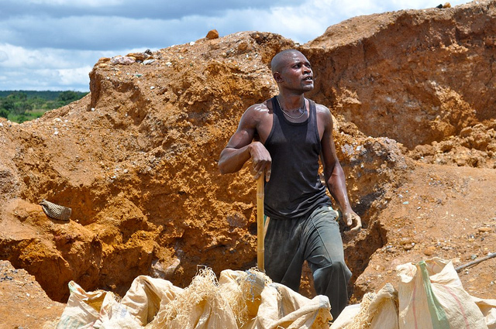**HOW DOES THIS EFFECT THE ENVIRONMENT?**

This effects the environment because space will be needed to dig in the grounds. Moreover, people would need to either volunteer or work to do this job. I would not like to dig it because it is a tiring job to do. Digging would create grounds in the spaces provided and the country would need to fix it.

**Fibre Optic**

Fibre optic is made out of glass and plastic. As both, they would need to have lots of stock for fibre optic to keep on working. Fibre optic is environmentally friendly. However, the biggest impact the fibre optic could have is on the naked eye. As the naked eye, we can see a certain amount of light and if the any person is exposed to the light, it could blind us or have a big impact on any person.

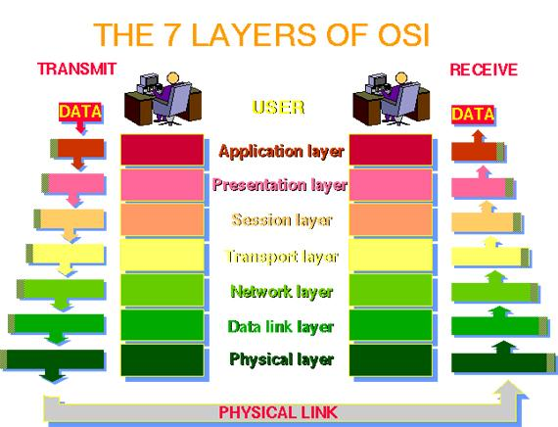

**OSI and TCP/IP model**

This is the model of the seven layers of the OSI model. This is the layers of how the data is travelled. The **application layer** is used through the address bar e.g. HTTP. **Presentation layer** is used so that no one can look at it. It is encrypted at this stage. **Session layer** is the part where it sends it off. **Transport layer** is when it is like the taxi. It takes it to the other layer. **Network layer** tracks the IP of the computer for it to be located. If it were within the same network, the data would travel faster. **Data link layer** is when it tracks the modem and uses that to get into the computer. **Physical layer** is the last part where it uses the cable to get to the destination.

**Reference**

<http://en.wikipedia.org/wiki/Coaxial_cable>

BTEC LEVEL 3 BOOK

<http://en.wikipedia.org/wiki/Optical_fiber>